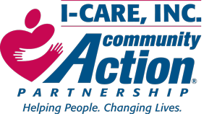

********Hiring ********Hiring *******Hiring *******
I-CARE, INC., a 501(c) (3), a private non-profit organization based in Iredell County with programs in Catawba and Alexander Counties, is seeking energetic, creative, knowledgeable, positive staff to fill Head Start and Early Head Start teaching positions within our centers.

What we offer:
$$$$1500.00 Sign on Bonus
Great Health insurance
Vision insurance
Free Dental insurance
Free life insurance
401k
Paid Holidays
PTO

Qualifications

Must be able to meet Minimum Qualifications: Child Development Associate (CDA) or working towards a degree in Early Childhood Education or related field, North Carolina Early Childhood Credential or the ability to enroll within 6 months of employment, able to complete North Carolina Health and Safety Training requirements, ITS-SIDS training or the ability to complete within 90 days of employment, computer literate, experience working with infants and toddlers, good oral, written and organization skills, reliable transportation.

Ask how you can join our team!
Contact Info:
Human Resource Department
Phone :704-872-8141 ext 126 Apply online at www.icare-inc.org

